Select Find Expense Reports from Main Menu
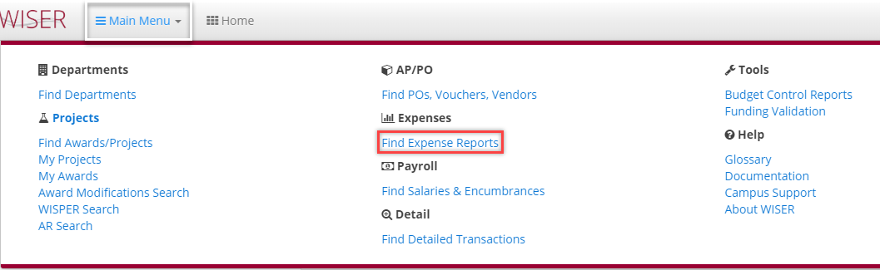
Find Expenses – Expense data from e-Reimbursement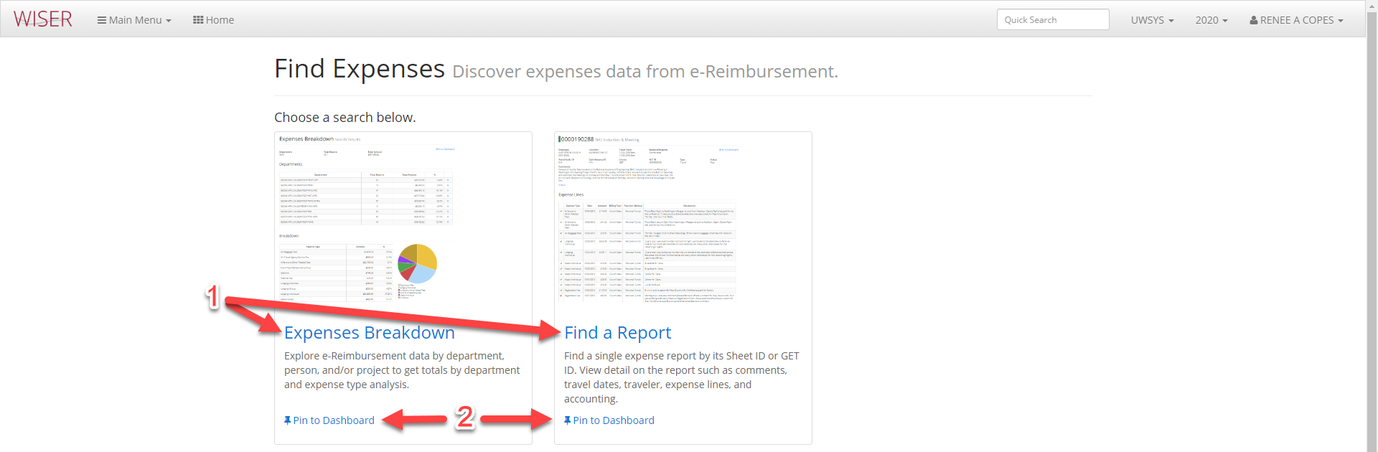
- Two view options
  - Expenses Breakdown
  - Find a Report
- Pin the search to your Dashboard

Expenses Breakdown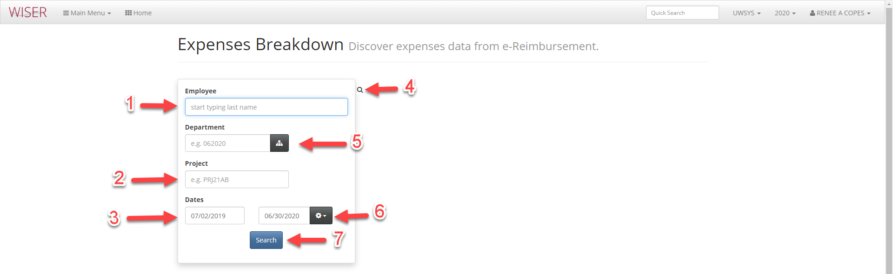
Enter criteria for search – the more criteria supplied, the narrower the search results.
There are sample entries populating search fields to assist with knowing what to enter.
- Begin typing last name – selectable possible match list populates
- Enter Project number
- Date – enter start and end range or use Date range selector (#6)
- Toggle between Search & Results screens
- Display Department picker or enter Department number in field
  - Picker allows you to find a department in the tree to select (helpful if you don’t know number)
- Date range selector
  - Last 30 days
  - Last Month
  - This Fiscal Year
  - Last Fiscal Year
  - Clear
- Begin Search with criteria entered

Search Results for Expenses Breakdown:
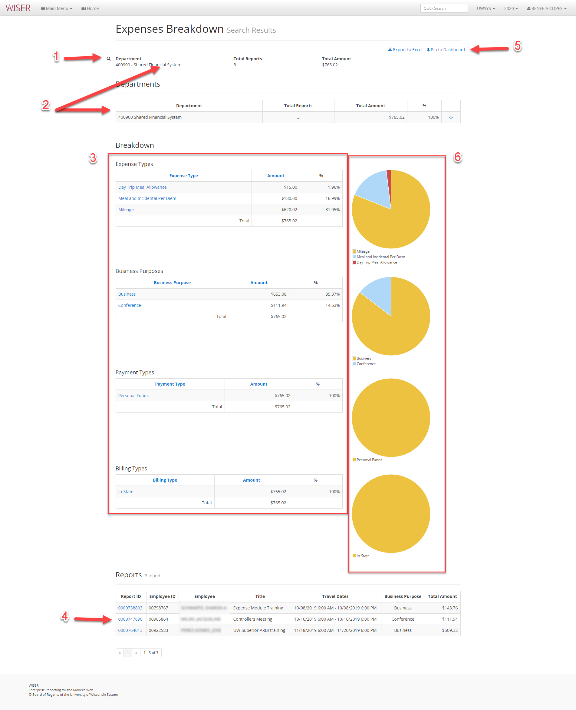

- Toggle back to search screen
- Search results summary
- Breakdown by type
  - Hyperlinks to additional details
  - Headers can be used to sort
- Report listing
  - Hyperlinks to individual reports
- Export to Excel and Pin to Dashboard (create tile) options
- Graph depiction of each breakdown

Find a Report


- Enter Report ID – example populated
- Additional entry hint pop-up when cursor is in field
  - Leading zeros are optional/Start with G to indicate GET ID
- Begin search with ID entered

Search results for Find Expense Report
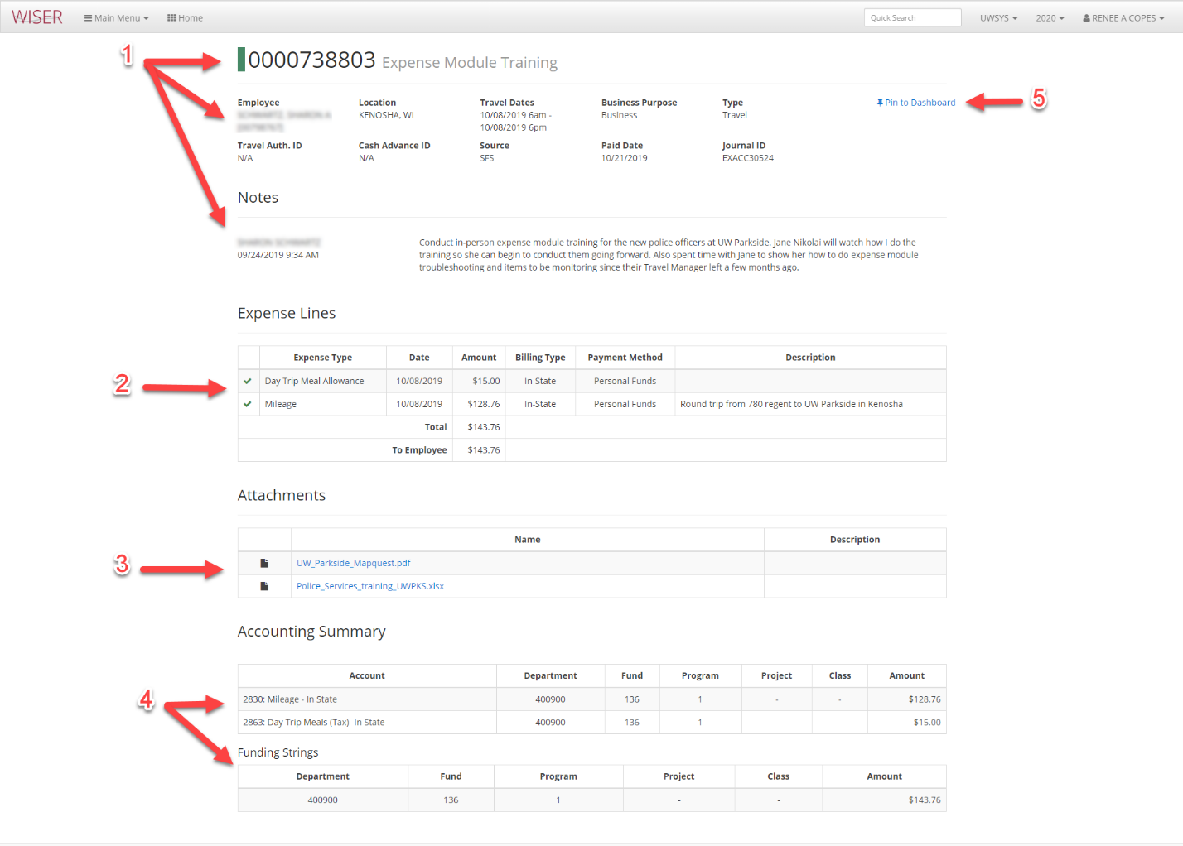

- Expense report details
- Breakdown of Expense Lines
- Attachment list – hyperlinks to document
- Accounting Summary
- Pin to Dashboard (create tile)

