Select Budget Control Reports from the Main Menu
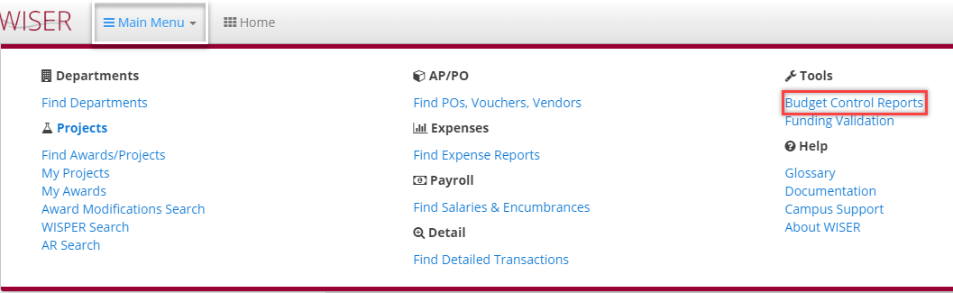
There are two types of Budget Control Reports – Department and Project
Department:
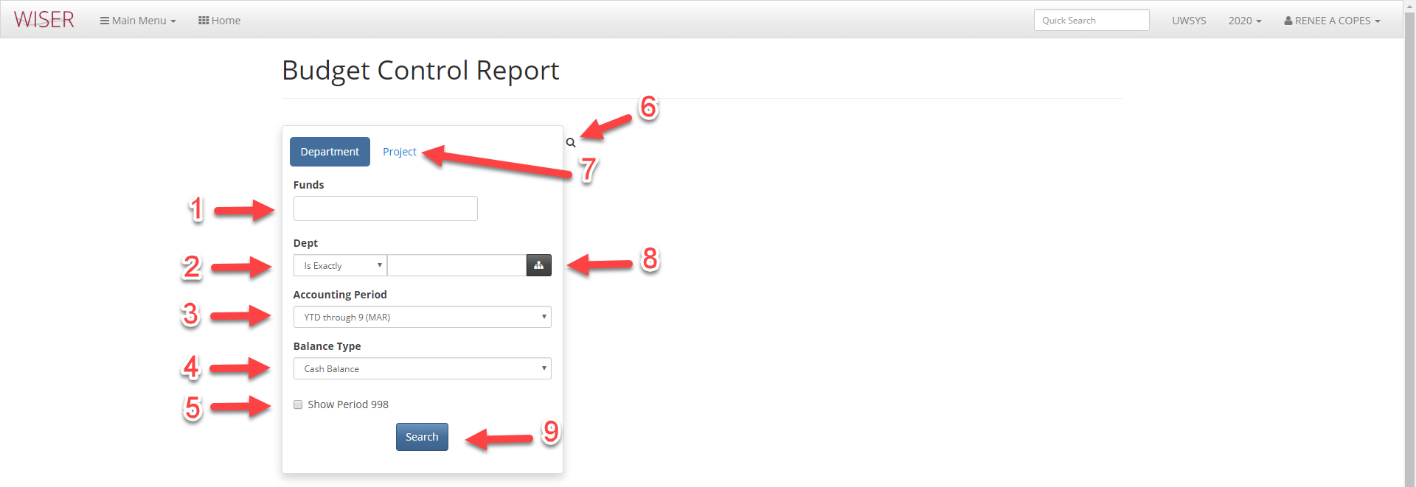
Enter criteria for search – the more criteria supplied, the narrower the search results.
- Fund
  - Type in fund and a “Add XXX” drop-down will appear, select to add that fund to criteria
    - Able to enter multiple funds
    - Leaving this field blank is equivalent to selecting All
- Department number
  - Options in dropdown: Is Exactly, Starts With
- Accounting Period
  - Drop-down gives you the option of YTD through each month of fiscal year
- Balance Type
  - Choose either Cash or Fund
- Toggle for including/excluding period 998
- Toggle between search results and search criteria
- Selector for either Department or Project Budget Control Report search
- Department picker
  - Useful when you don’t know the Department number
- Begin search using criteria supplied
Project:
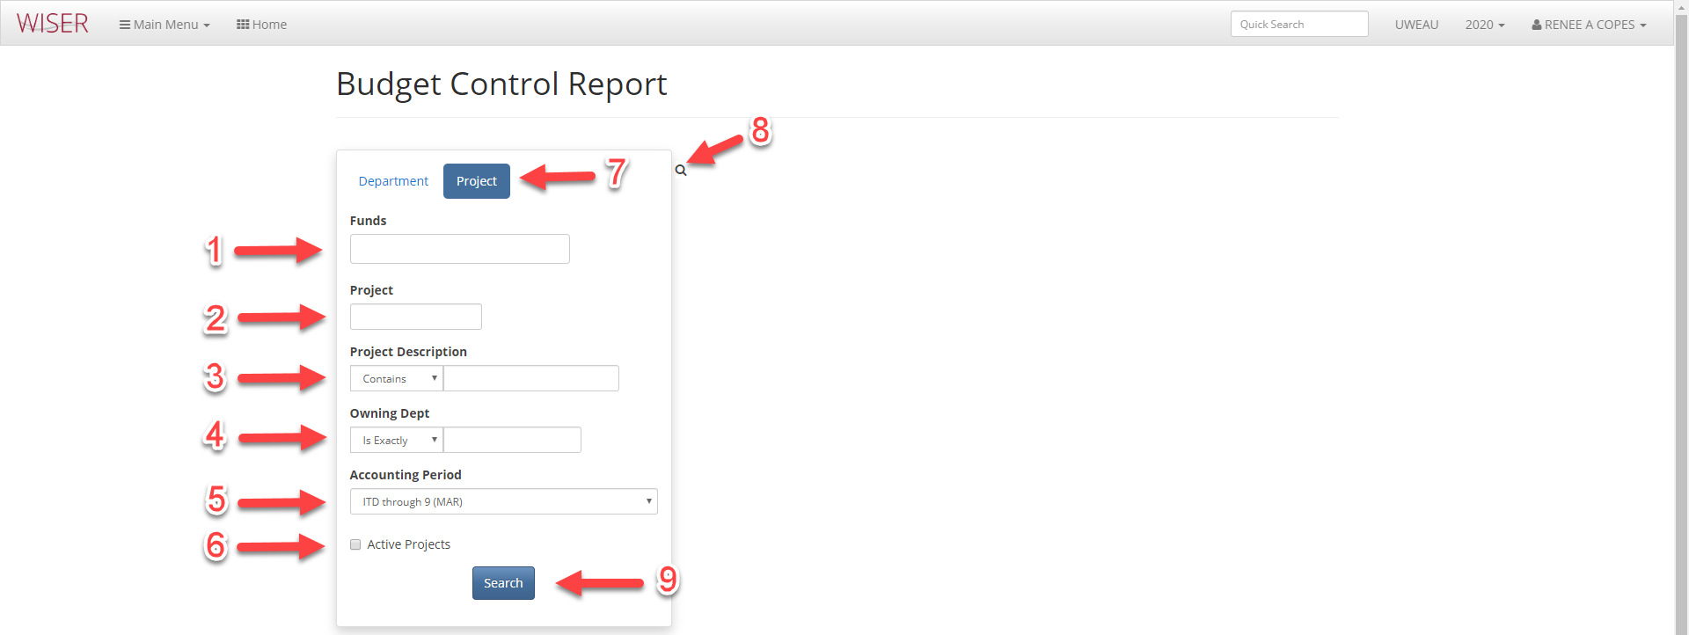
Enter criteria for search – the more criteria supplied, the narrower the search results.
- Fund
  - Type in fund and a “Add XXX” drop-down will appear, select to add that fund to criteria
    - Able to enter multiple funds
    - Leaving this field blank is equivalent to selecting All
- Project – must enter entire Project number
- Project Description
  - Options in drop-down: Is Exactly, Starts With, Contains
- Owning Department
  - Drop-Down options: Is Exactly, Starts With
- Accounting Period
  - Drop-down gives you the option of YTD through each month of fiscal year
- Toggle to limit search all, or only Active Projects.
- Selector for either Department or Project Budget Control Report search
- Toggle between search results and search criteria
- Begin search using criteria supplied

Results from Project Budget Control Report using criteria of Fund 233:
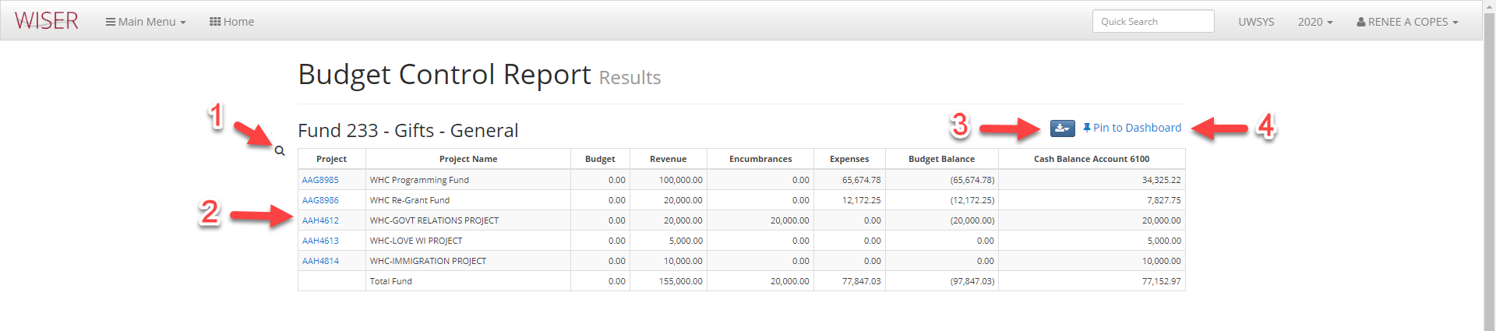
- Toggle back to Search screen
- Hyperlinks to individual Project’s Summary Report
- Export to Excel or PDF
- Pin these results to Dashboard (create tile)

