Administration options in Main Menu
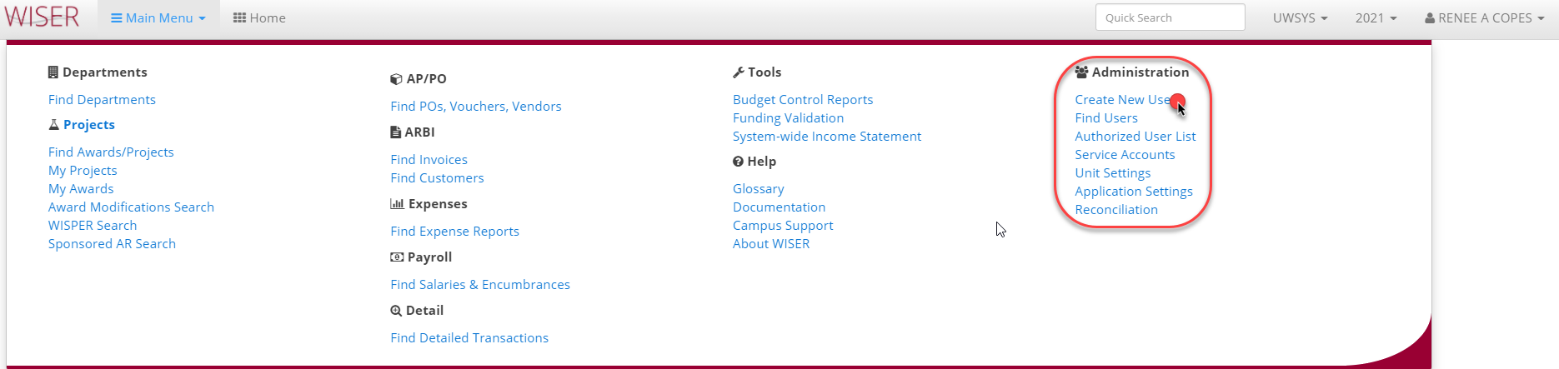
Create New User
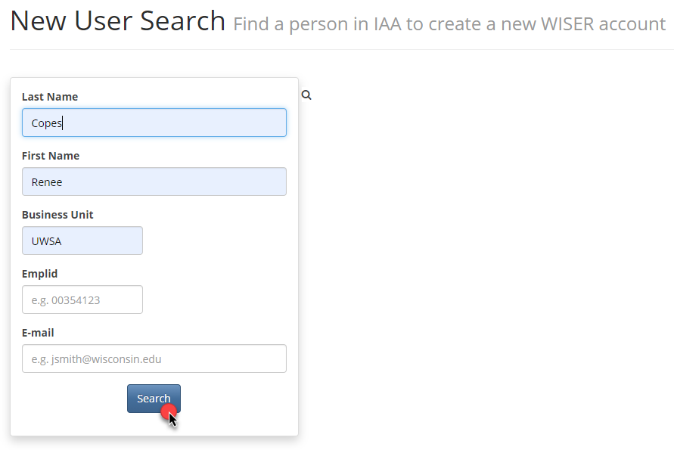
Enter search criteria to locate desired user and select Search
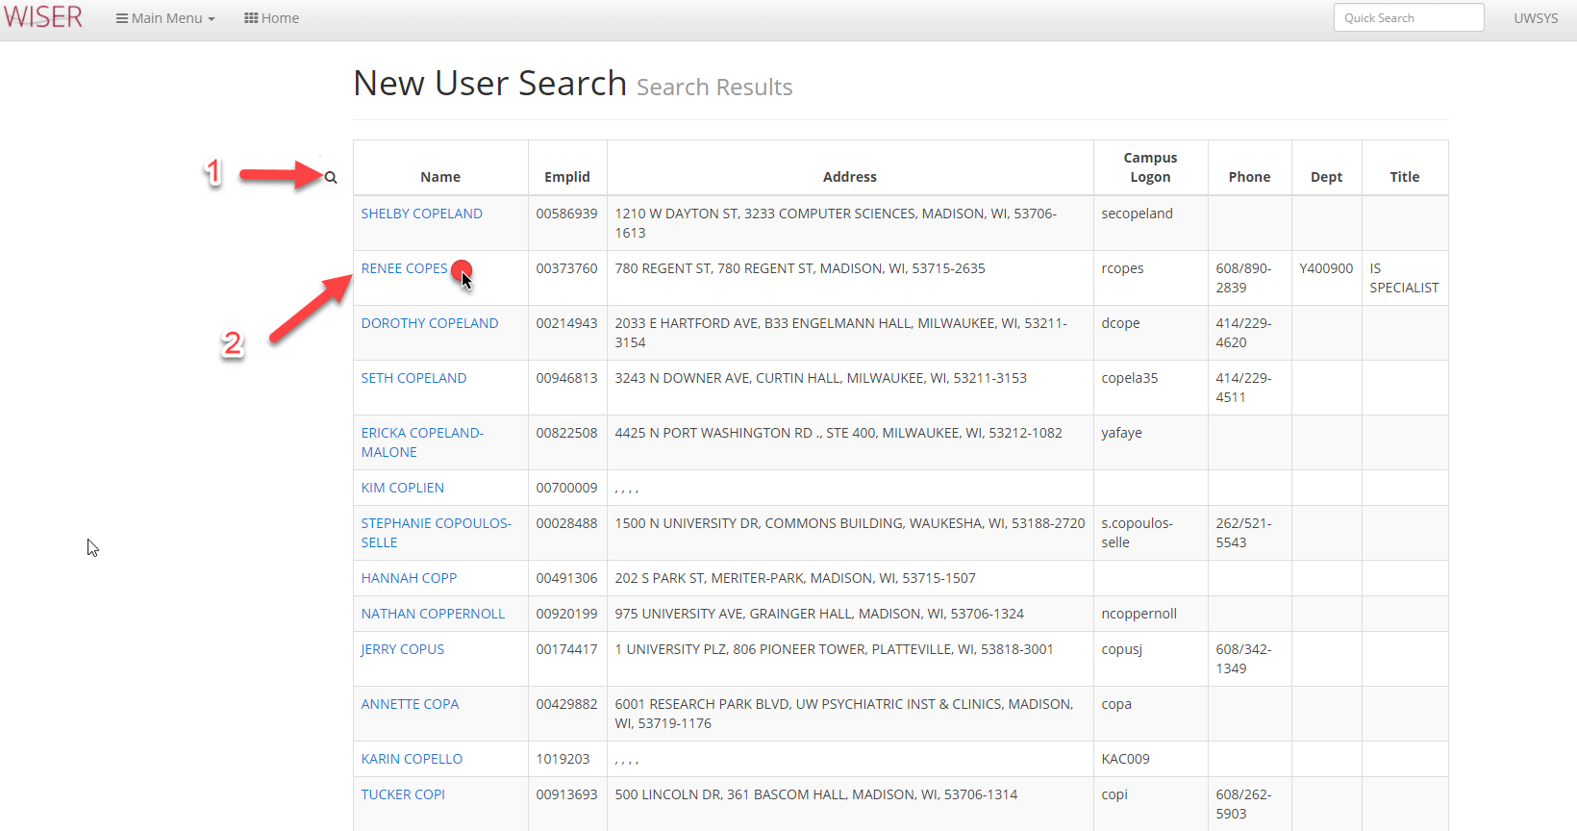
1. Toggle back to search criteria screen
2. Select Name to create user account
Message when Name selected already has a WISER account associated with it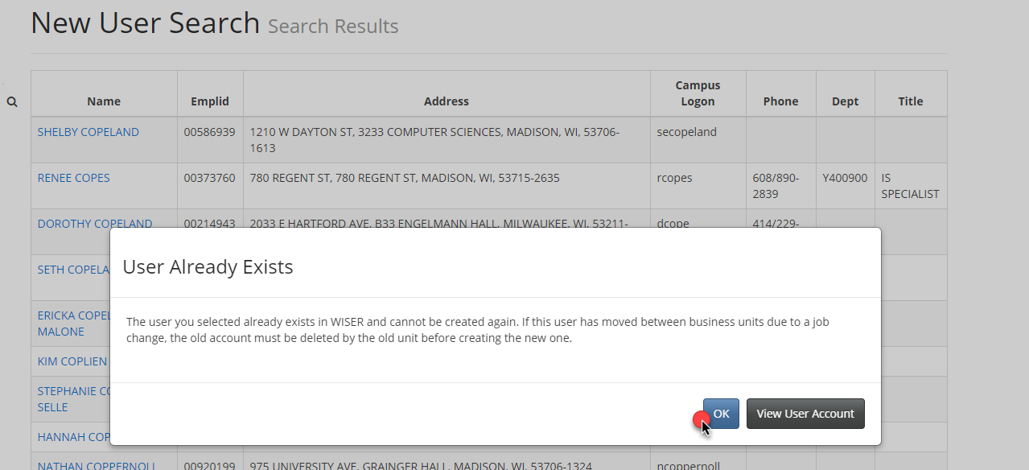
Select OK – follow given direction to allow for new account creation. Can View User Account if more information on current account is needed.
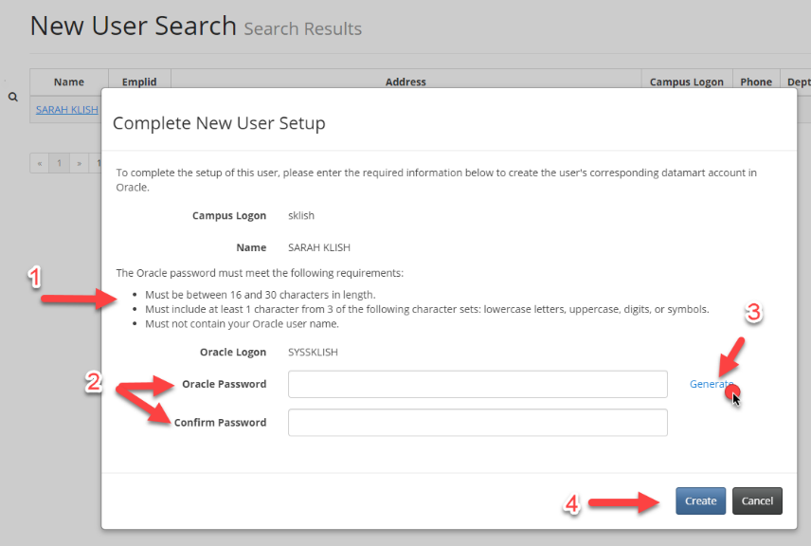
Result when Name selected for account creation
*this password & Oracle logon are used for accessing the datamart, not the WISER application. If the user intends on accessing the datamart (with a tool such as SQL Developer or Hyperion) they can change this password by using the option within their WISER User settings – no need for you to save & share this password unless you want to supply the user with it.
- Password security requirements (if not met error will appear when Create selected)
- Manual entry and confirmation of Oracle password.
- Will autofill a password that meets the security requirements.
Message shown when Generate is selected
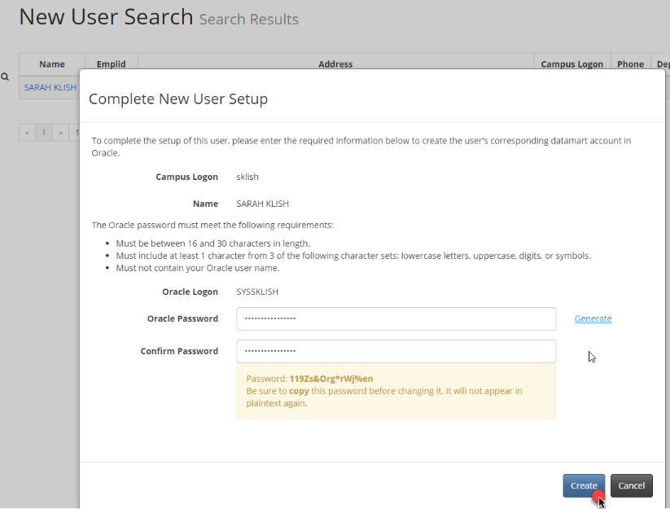
Select Create
Granting access
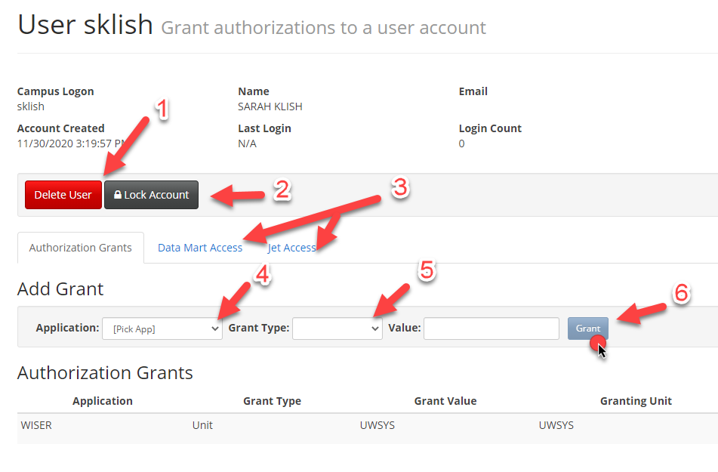
- Delete user
- Lock user account
- Data Mart (SFMRT) Access select toggles for desired access/JET Access *
- Application – select WISER
- Grant Type – select from options in drop down listing (will usually be “Unit”)
- Select Grant button to create user account

*When Data Mart Access tab is selected in User setup:
The majority of WISER users do not utilize accessing the DataMart
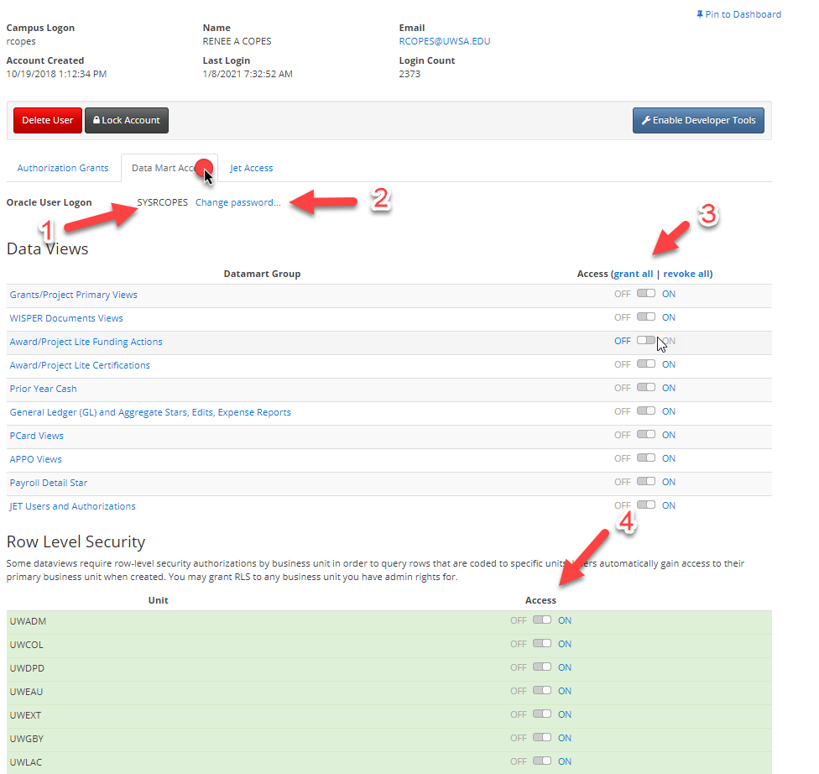
- Oracle User Logon – used when accessing Datamart (SFMRT) using a tool such as SQL Developer, NOT for accessing WISER application.
- Option to change the Oracle password
- Toggles for Datamart group permissions
- Toggles for row-level security permissions
*When Jet Access tab is selected in User Creation:
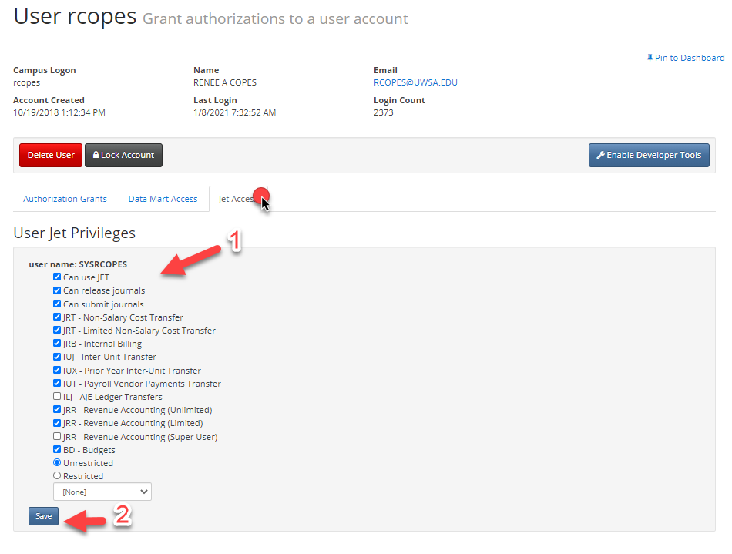

- Checkbox options for JET (Journal Entry Tool) permissions
- Save changes

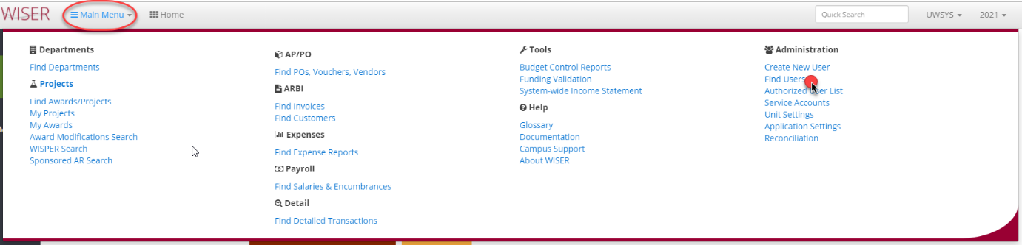

Find Users
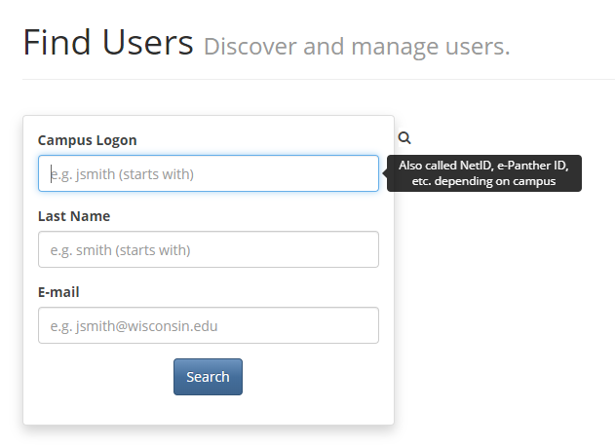
Search criteria options with entry format shown and hover help
Results when Campus Logon criteria of “Xiong” searched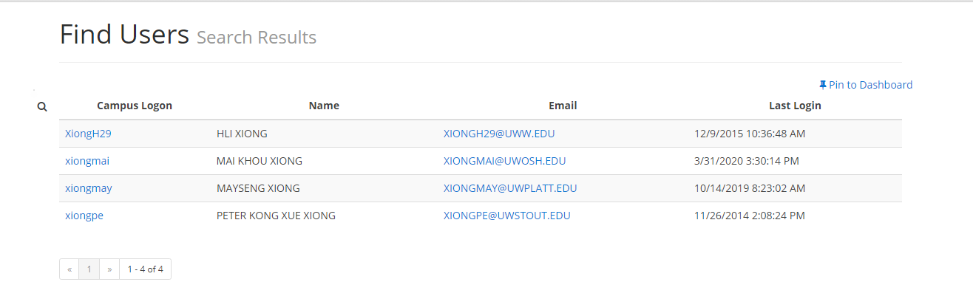
Campus Logon hyperlink XiongH29 selected - Same screen as shown above (in create new user)
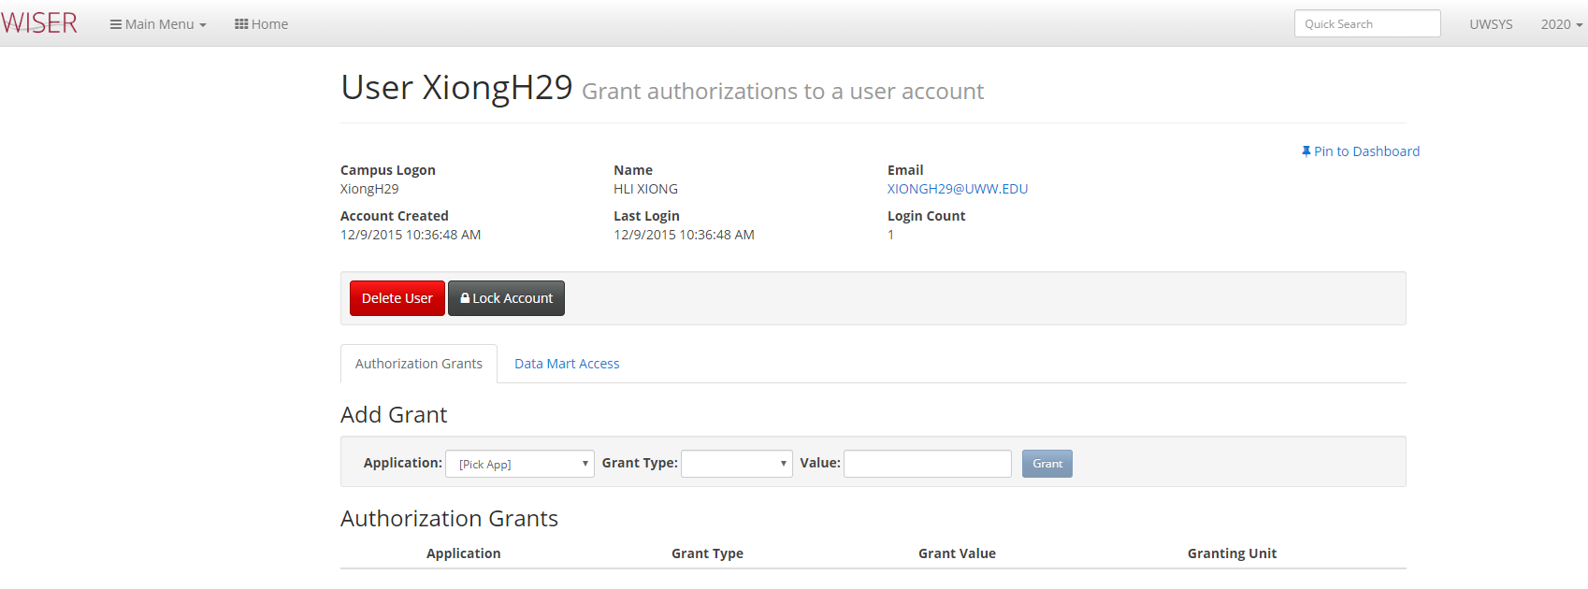

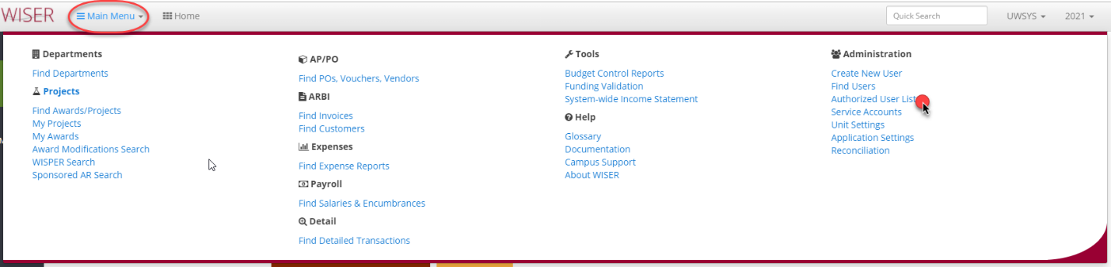
Authorized User List
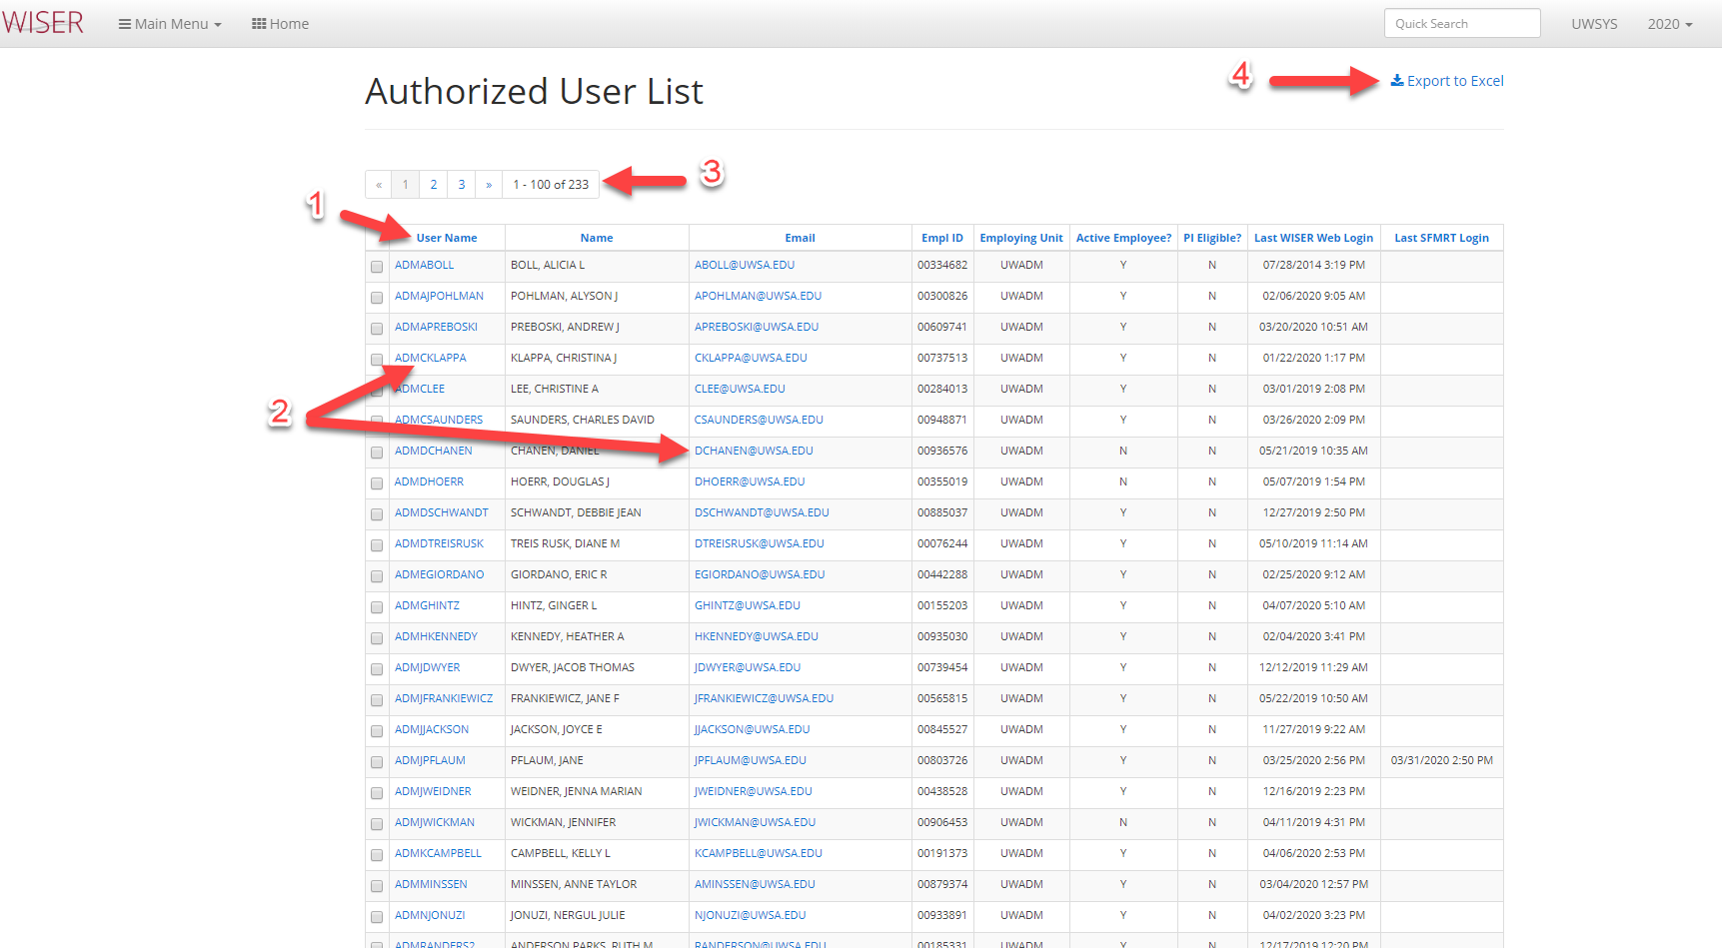
- Column headers can be used to sort list
- Hyperlinks to User account and create email
- Page navigator
- Export to Excel
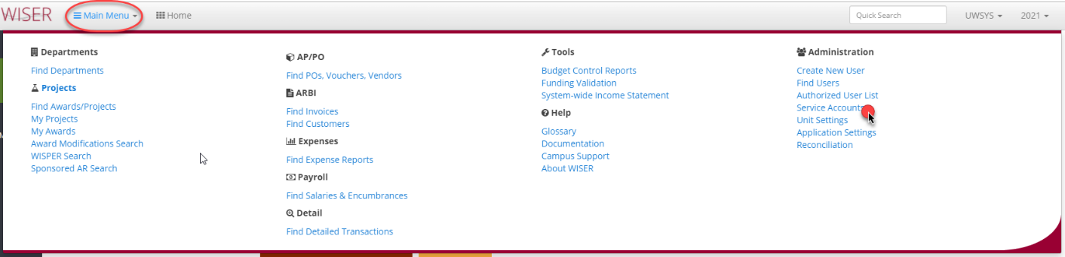

Service Accounts – non-User accounts used for accessing the datamart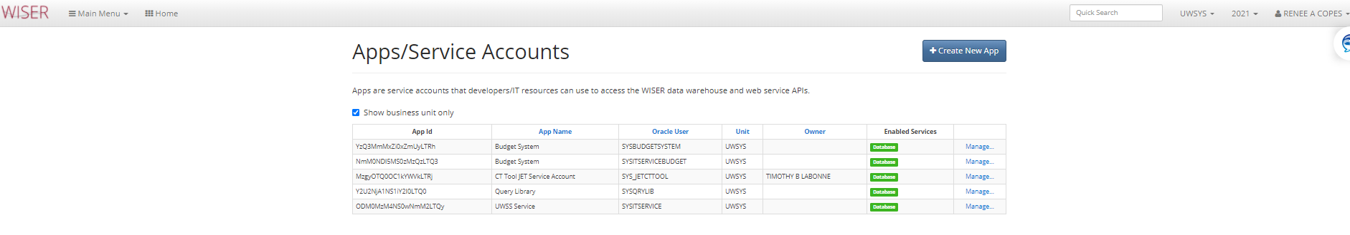

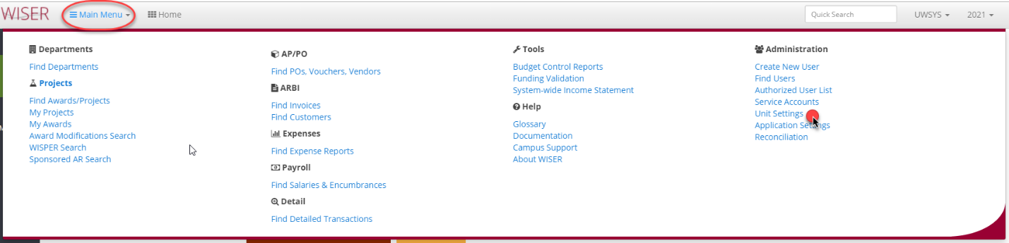
Unit Settings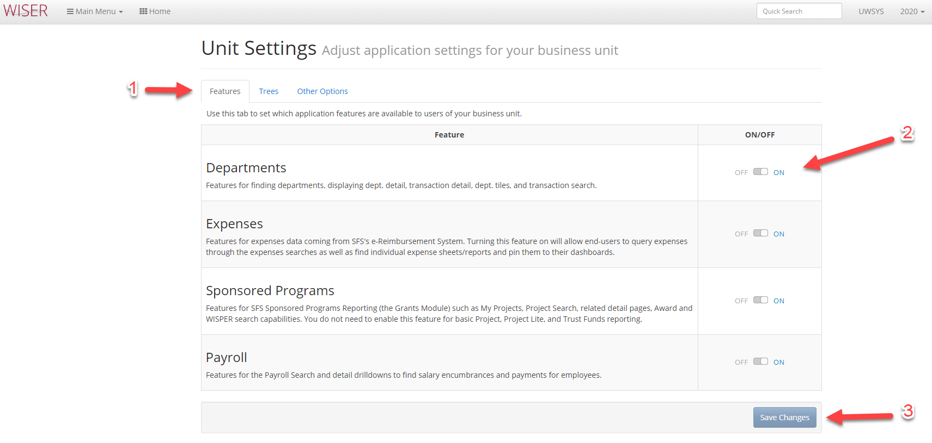
- Tabs containing different setting areas
- Off/On selector for features
- Save Changes
Trees tab selected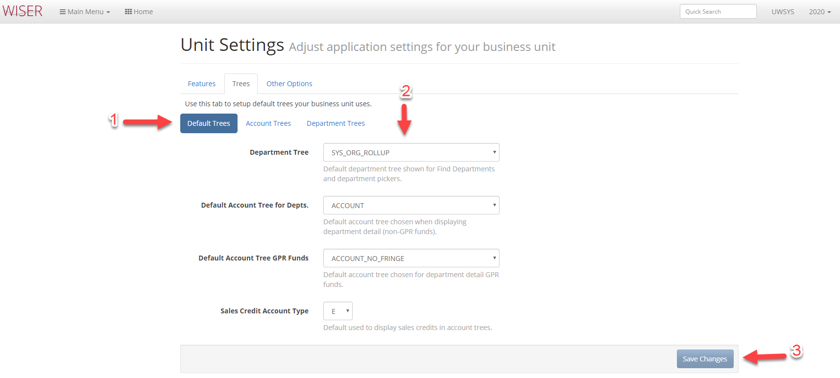

- Tree groups
- Drop down selectable options for Default Trees
- Save Changes

Continued on next page

Account Trees option selected
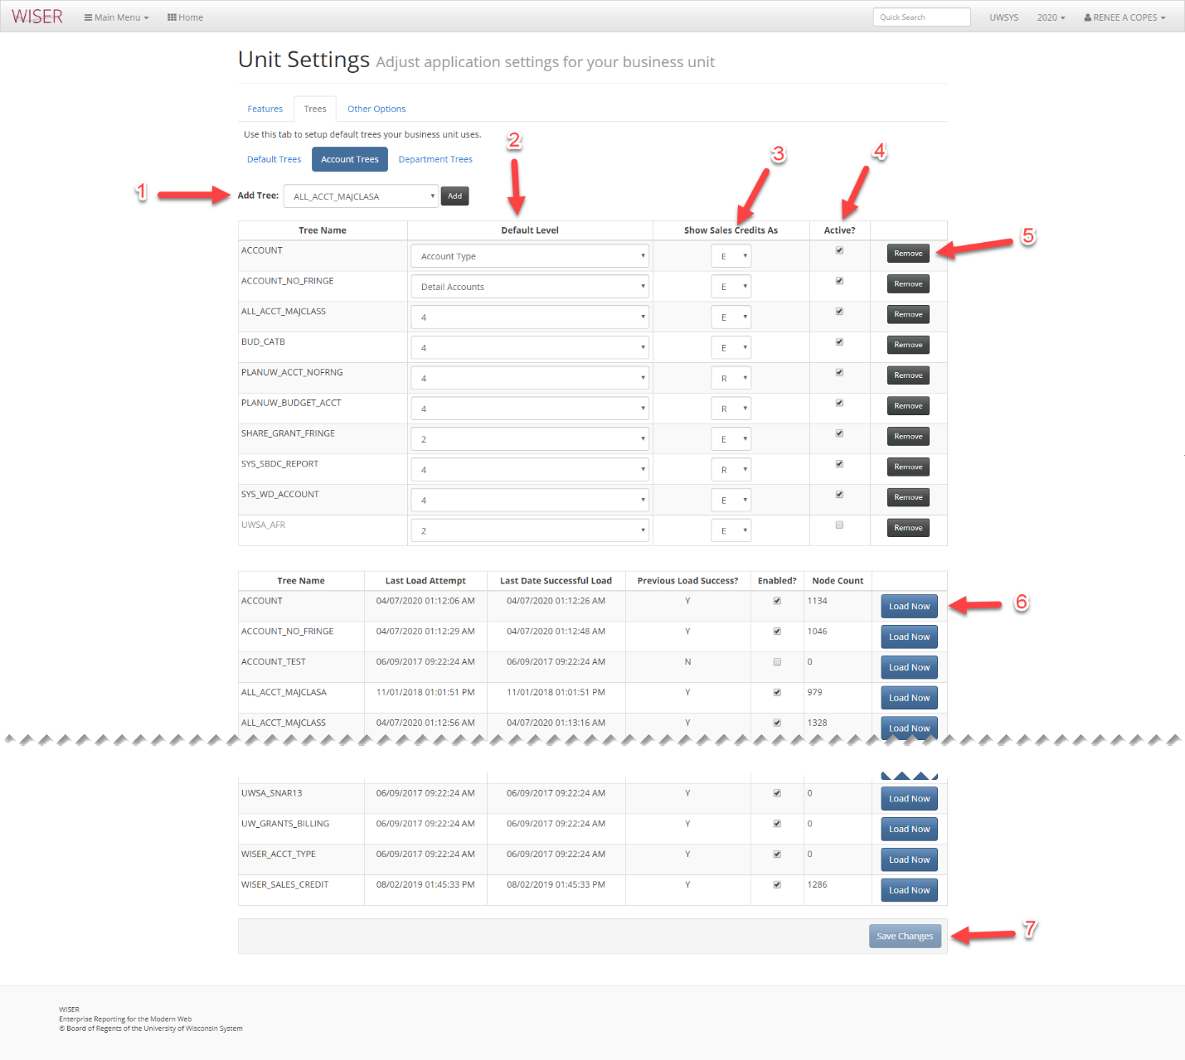
- Drop down to select tree to add
- Set tree Default Level
- Show Sales Credits as E/R
- Active or inactive toggle
- Remove tree
- Load corresponding tree
  - Unlike WISDM, WISER has one copy of an account tree. Inactive accounts should be inactivated, but left in the tree so that they can be reported on in past FY.
- Save changes
Department Trees tab selected 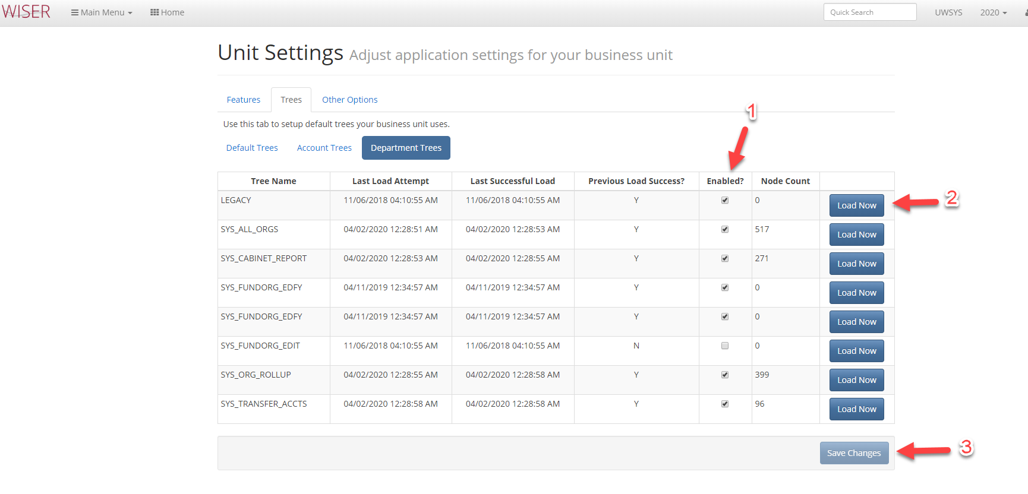
- Enabled/disabled toggle
- Load corresponding tree
  - To load a previous year’s version of the tree, you need to adjust the FY in the top menu bar to the desired year before selecting Load Now.
- Save changes
Other Options tab selected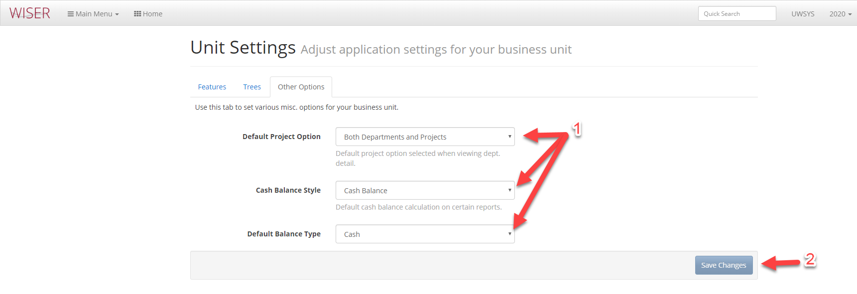
- Select Unit default settings
- Save Changes

Note: Application Settings are only available to someone in the System Administration WISER Unit Admin position – Campus Unit Admins will not see this option
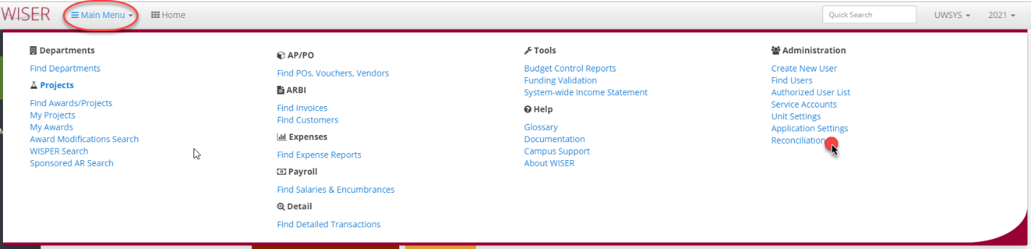
Reconciliation
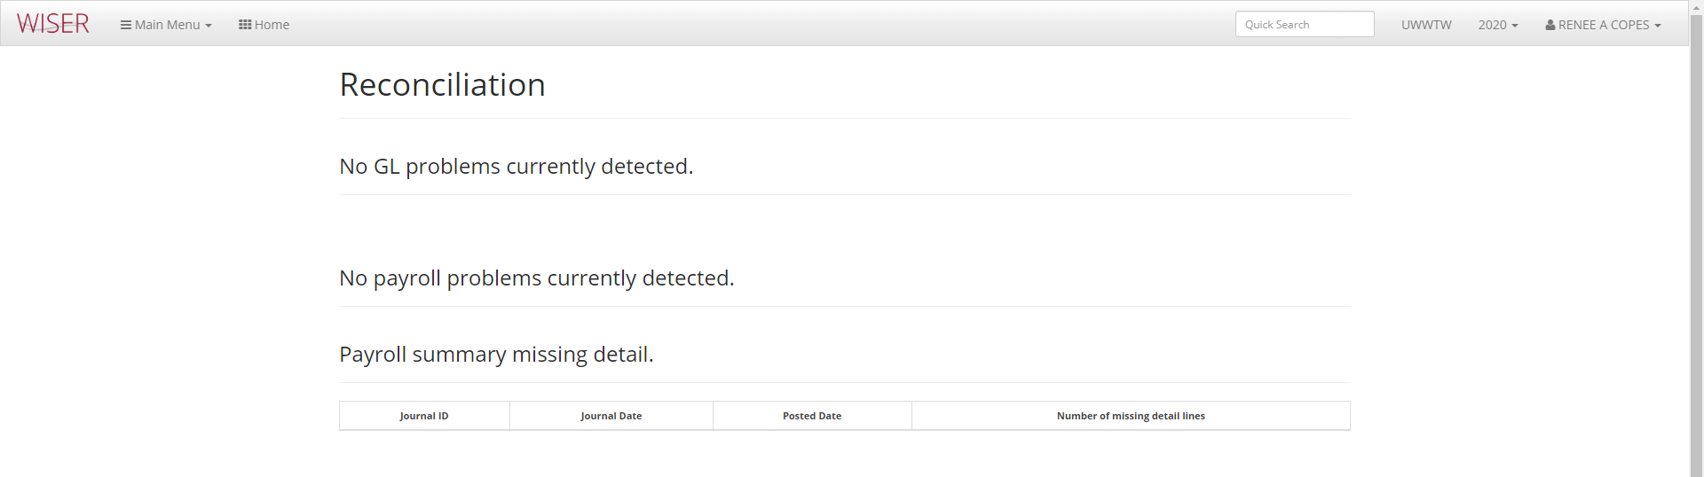
This area would contain information on GL issues that had occurred with the ETL (extract transform & Load) of data from SFS. The Database Status icon on the Home Screen is also useful for this information.

