This document will illustrate WISER common navigation and options.

When logging into WISER for the first time (before any customizations) you will be presented with this screen:
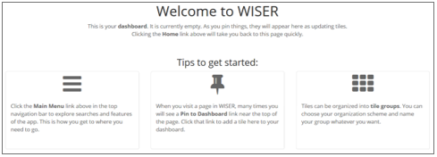
Once you create a tile (like a bookmark to a WISER page) the above introductory screen will no longer be shown & you will be taken to your dashboard (also referred to as Home Page) after logging in.
TILES-CREATING

Creating a tile (also referred to as Pin to Dashboard) replaces the WISDM Favorites function.
When you see this on a page- you can select it to create a tile, which is a shortcut placed on your home page. This option is available from various pages in WISER.
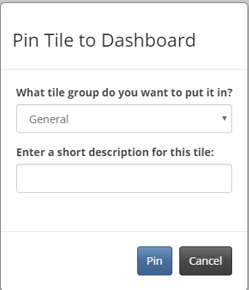
When Pin to Dashboard is selected, a pop-up screen allows you to set the traits of the new tile. The default tile group is General, but selecting the drop down allows you to create a new group (which will appear as a new tab on the home page) or select another existing group to add the tile. What you enter in the short description textbox will be displayed on the tile.

HOME PAGE/DASHBOARD
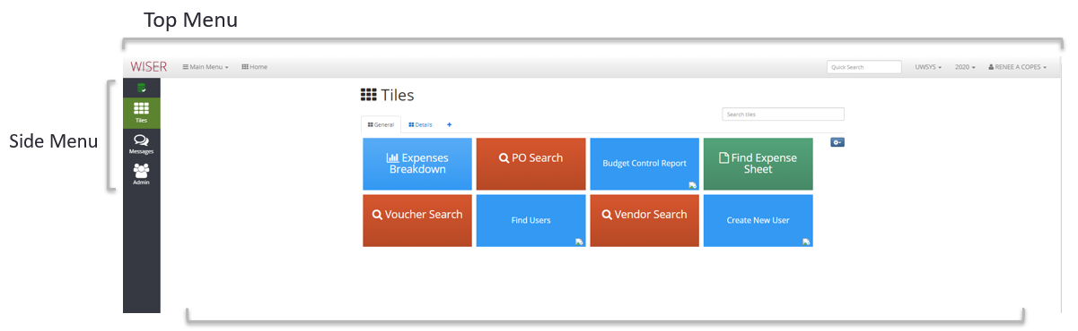
*The options available will depend on user permissions.
The Top Menu is always visible & available for use when navigating through WISER:
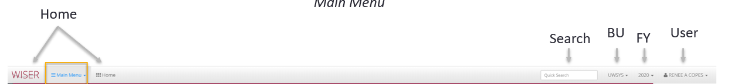
Selecting either the WISER text or the Home icon will take you back to your Dashboard.
Selecting Main Menu will display a menu with the options available to you.
Quick Search text box allows you to enter a piece of information (Dept/Project/text) for which WISER will create a listing of occurrences found. The displayed items are selectable and will navigate you to that page.
The Business Unit that WISER is currently reporting on is shown and, if you have permissions to multiple, a drop down is available to switch to another. Switching Business Units is not enabled on all screens.
Fiscal Year is a drop-down selector to identify and use a different year.
User displays the current user and the drop-down lists options for Settings and Sign Out.
User Settings opens a page that allows you to select a color theme to apply to your tiles/entities.
The Datamart tab in User Settings contains information on accessing the WISDM database.
Selecting Sign Out will log you out and close the WISER application.
The Side Menu is only visible when the Dashboard/Home Page is displayed

This icon is the database status indicator. When selected a pop-up will display the status, start, and end times of the daily ETL (Extract, Transform, Load) of SFS data. There is a hyperlink for Details, which will show all the processes run during the ETL with their start & end times. A second hyperlink, Daily Verify, displays the detail on journals loads completed for the date selected and contains hyperlinks to the journal’s detail page.

When selected this icon returns you to your Dashboard


The Message Center will display current messages with options to view inactive messages or create new. The icon will have an alert displayed if there is a new message to be viewed.

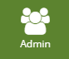
The Admin area (visible if you have the permissions) contains options for: Find Users, Create New User, Authorized User List, Change Settings.

MAIN MENU
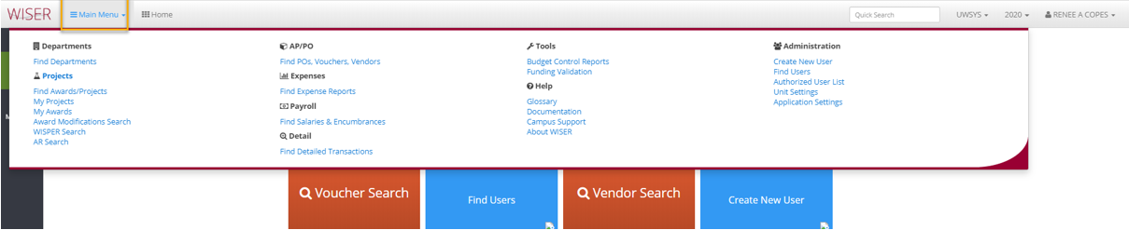
Main Menu lists all the pages/functions you, as a user, have permission to utilize.
Each item is a hyperlink to the page/search/report identified in the link text. Each of these items is explained in detail within their own training document available at: https://www.wisconsin.edu/sfs/reporting/wisdm-and-wiser/#wiser-training-materials

TILES
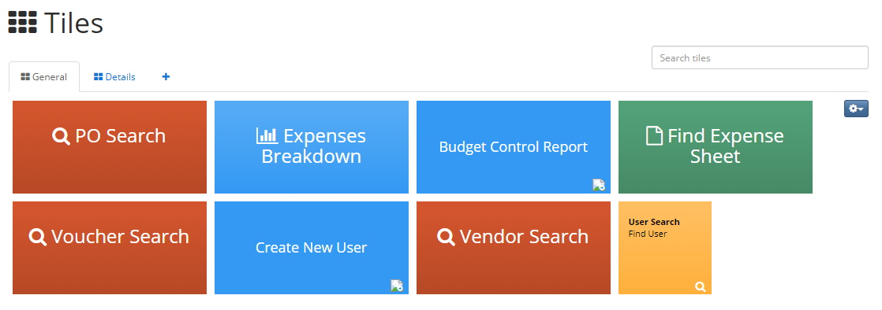
Tiles are shortcuts to pages within WISER (or outside websites) that can be created either by selecting the Pin to Dashboard option on a page or through the settings available on this page.
The General tab is the default available when creating a tile. Additional tabs (tile groups) are created when the option to Create New Group is selected during tile creation. A new group can also be created by selecting the + symbol next to the existing tabs.
Tiles can be:
- Selected to navigate to the page/item they represent.
- Dragged & dropped to change displayed order.
- Unpinned (deleted) by selecting the X that appears when hovering on a tile.
- Resized by selecting the up or down arrow that appears (if option is available) when hovering on a tile.
- Searched for by entering text in the Search Tiles textbox (all tabs are searched, and results displayed).
The Settings icon is for Tile Group tools which allow you to delete or rename a group as well as create a new tile.

COMMON OPTIONS FOR SEARCH CRITERIA ENTRY
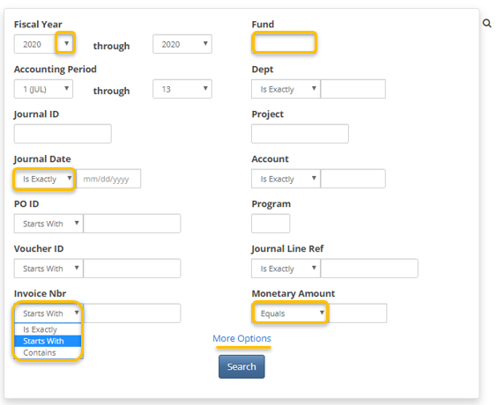
When performing a search, the more criteria entered the narrower the search and the fewer results returned.
Each search screen has input options specific to that type of search. However, there are common types of input.
- Drop-Down allows you to pick from a list of available options.
- Date filter options include: Is Exactly, Before, After, and Between.
- Filtered numerical or text. Options are Is Exactly, Starts With, and Contains.
  - “Contains” is the least efficient search criteria
- Textbox entry is free form alpha numeric entry.
  - No input is equivalent to “all”
- Monetary amount filters are Equals, Less Than, Greater Than, and Between.
- The More Options toggle expands the displayed search criteria with additional input options.
The Search button will begin the search using the criteria entered.

SEARCH RESULTS NAVIGATION/OPTIONS

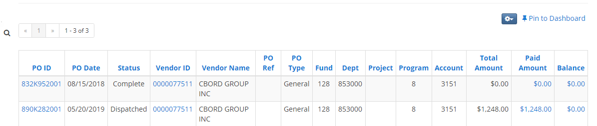

The results listed from searches have common elements:
- The Magnify glass icon toggles you between the Search Criteria screen and the results.
- If there are too many results to display on one page, a page navigator will be available.
- Column headings can be used to sort results.
- Blue items in the list are hyperlinks to the item identified (PO, Voucher, Journal etc.)
Many Hover Hints are available throughout the WISER application:
